

IT342-G2
System Integration and Architecture

System Design Document (SDD)

Project Title: Paluto
Prepared By: Auditor, Mechole Angelou M.

Version: 0.1
Date: February 23, 2026
Status: Final

REVISION HISTORY TABLE
Version | Date | Author | Changes Made | Status
0.1 | 2-23-2026 | Auditor, Mechole | Initial draft | Final
0.2 | [Date] | [Your Name] | Added API specifications | Review
0.3 | [Date] | [Your Name] | Updated database design | Review
0.4 | [Date] | [Your Name] | Added UI/UX designs | Review
0.5 | [Date] | [Your Name] | Incorporated feedback | Revised
0.6 | [Date] | [Your Name] | Final review and corrections | Final
1 | [Date] | [Your Name] | Baseline version for development | Approved

TABLE OF CONTENTS
Contents
EXECUTIVE SUMMARY 4
1.0 INTRODUCTION 5
2.0 FUNCTIONAL REQUIREMENTS SPECIFICATION 5
3.0 NON-FUNCTIONAL REQUIREMENTS 8
4.0 SYSTEM ARCHITECTURE 9
5.0 API CONTRACT & COMMUNICATION 10
Authentication Endpoints 11
User Registration 11
User Login 11
6.0 DATABASE DESIGN 13
7.0 UI/UX DESIGN 14
8.0 PLAN 17

EXECUTIVE SUMMARY
1.1 Project Overview
Paluto is a specialized booking platform designed to bridge the gap between professional home cooks and busy families or professionals. Unlike standard food delivery apps, this system facilitates on-site meal preparation services, allowing customers to have personalized meals cooked directly in their own kitchens. The system includes a Spring Boot backend API, React web application, and Android mobile app, all integrated to provide a seamless appointment booking across platforms.
1.2 Objectives
- Develop a fully functional Service-Booking platform with authentication, multi-user roles, cook portfolios, appointment booking scheduling, and service rating.
- Implement a three-tier architecture using Spring Boot (backend), React (web), and Android (mobile)
- Create RESTful APIs for communication between all system components
- Design a responsive user interface that works consistently across web and mobile platforms
- Deploy all system components to production-ready environments
1.3 Scope
Included Features:
- User registration and authentication (email/password)
- Google login integration
- Cook portfolio (add, remove, update certificates, menu, specialties, and rates)
- Transactional Appointment booking system
- Cook Service Rating System
- Payment Gateway Integration (sandbox)
- Email notification system
- In-app notifications
- Admin panel
- Native Android mobile application
- PostgreSQL database with relational schema
Excluded Features:
- Push notifications
- Advanced analytics dashboard

1.0 INTRODUCTION
1.1 Purpose
This document serves as the comprehensive design specification for the Paluto Booking system. It provides detailed requirements, architectural decisions, API contracts, database design, and implementation roadmap to guide development and ensure all components integrate seamlessly.

2.0 FUNCTIONAL REQUIREMENTS SPECIFICATION
2.1 Project Overview
Project Name: Paluto
Domain: Service-Booking platform
Primary Users:
- Customers
- Cooks
- Administrator

Problem Statement: Busy professionals and families struggle to maintain healthy eating habits due to lack of time, often relying on unhealthy fast food.
Solution: A specialized booking platform that connects these individuals with home cooks for on-site meal preparations.
2.2 Core User Journeys
Journey 1: First-time customer booking a service
- Customer opens the web or mobile application
- Clicks "Sign Up" and creates an account
- Customer logins with the registered account
- Browse cook portfolios to view specialty menus and hourly rates
- Selects a cook clicks “Book Appointment”
- Selects specific date, time, and menu for the home cooking
- Confirms the booking and provides the service address
- Receives a booking confirmation once the cook accepts booking
- After the service, the customer rates the cook.
Journey 2: Cook accepts a booking
- Cook registers and completes their profile with certification/ specialties
- Sets hourly rate and uploads specialty menus
- Receives a notification for a new booking request
- Navigates to “My bookings” tab
- Click booking request and review details and confirm the schedule
- After the service, the cook marks the appointment as completed.

Journey 3: Admin manages users
- Admin logins into the web or mobile application
- Navigates to “users” section
- Click user details
- View user details
2.3 Feature List (MoSCoW)
MUST HAVE
- User authentication (register, login, logout)
- Role based access (customer, cooks, admin)
- Cook portfolio (certification, menus rates)
- Appointment booking (date, time, menu, cook)
SHOULD HAVE
- Cook Service rating
- Booking history
- Google login integration
- Payment gateway integration
COULD HAVE
- Favorite Cooks
- Cook filtering
- Cook dashboard
- Email notification
- In app notification
- Responsive design for all screen sizes
WON'T HAVE
- Real payment processing
- Advanced analytics
- Multi-language support
- Real-time GPS tracking of the cook
2.4 Detailed Feature Specifications
Feature: User Authentication
- Screens: Customer Registration, Customer Login, Cook Registration, Cook Login, Forgot Password
- Fields: First name, Last name, address, phone number, Email, Password, Confirm Password
- Validation: Email format, password strength, uniqueness, phone number format,
- API Endpoints: POST /auth/register, POST /auth/login
- Security: JWT tokens, password hashing with bcrypt
Feature: Cook portfolio
- Screens: Portfolio View (Public), Portfolio edit (Cook)
- Display: Menu, rate, specialties, certification/s
- Functions: Add/edit menu, update rates, upload/ remove certifications.
- API Endpoints: GET /cook, GET /cook/{id}/ portfolio, GET /cook/portfolio/items, PUT /cook/portfolio/details
Feature: Appointment Booking
- Screens: Booking form, Appointment Summary, Booking History
- Functions: Select a cook, choose schedule (date & time), select menu, submit booking request, accept booking
- Data Collected: Service address, date/time, and menu.
- API Endpoints: POST /bookings, GET bookings/{id}, PUT /bookings/{id}/status
Feature: Service Rating
- Screens: Post-service Rating form, Cook profile rating section
- Fields: Star rating(1-5)
- Persistence: Ratings are linked to the cook’s profile and appointment.
- API Endpoints: POST /ratings, GET /ratings/cook/{cookdId}
2.5 Acceptance Criteria
AC-1: Successful User Registration
- Given I am a new user
- When I enter valid firstname, lastname, phonenumber, address, email and strong password
- And confirm password matches
- And click "Create Account"
- Then my account should be created
- And I should be redirected to login page
AC-2: Cook Portfolio Creation
- Given I am logged in as a cook
- When I navigate to my portfolio dashboard and add/edit my specialty menus, hourly rates, and certifications.
- And I save the changes
- Then the updated information should be visible to customers when they search for cooks
- And the certifications should be stored and available for Admin verification.

AC-3: Appointment Booking Flow
- Given I am logged in as a "Customer"
- When I select a cook's profile and choose an available date and time slot.
- AndI provide the service location/address and confirm the booking request.
- Then the system should create a "Pending" appointment record.
- And the cook should see the new request in their management dashboard.

3.0 NON-FUNCTIONAL REQUIREMENTS
3.1 Performance Requirements
- API response time: ≤ 2 seconds for 95% of requests
- Web page load time: ≤ 3 seconds on broadband
- Mobile app cold start: ≤ 5 seconds
- Support 30 concurrent users
- Database queries complete within 500ms
3.2 Security Requirements
- HTTP for all communications
- JWT token authentication
- Password hashing with bcrypt
- Role-based access control
- SQL injection prevention
- XSS protection
- Rate limiting: 100 requests/minute per IP
- Admin endpoints require role verification
3.3 Compatibility Requirements
- Web Browsers: Chrome, Firefox, Safari, Edge (latest 2 versions)
- Android: API Level 24+ (Android 7.0+)
- Screen Sizes: Mobile (360px+), Tablet (768px+), Desktop (1024px+)
3.4 Usability Requirements
- New users should be able to complete their first cook booking within 5 minutes.
- Consistent navigation across all pages
- Clear error messages with recovery options

4.0 SYSTEM ARCHITECTURE
4.1 Component Diagram
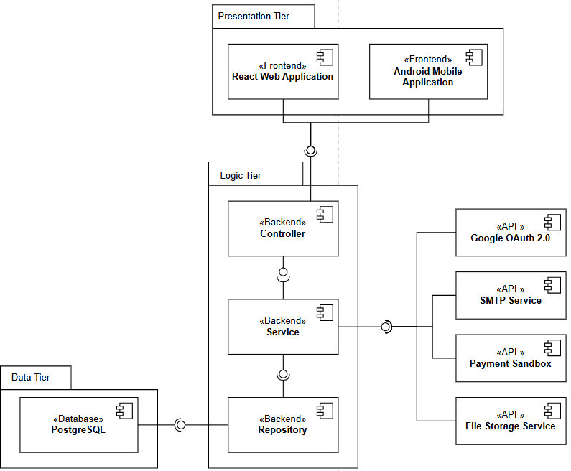

Technology Stack:
- Backend: Java 17, Spring Boot 3.x, Spring Security, Spring Data JPA
- Database: PostgreSQL 14+
- Web Frontend: React 18, TypeScript, Tailwind CSS, Axios
- Mobile: Kotlin, Retrofit, Room
- Build Tools: Maven (Backend), npm/yarn (Web), Gradle (Android)
- Deployment: Railway/Heroku (Backend), Vercel/Netlify (Web), APK (Mobile)

5.0 API CONTRACT & COMMUNICATION
5.1 API Standards
Base URL | https://[server_hostname]:[port]/api/
Format | JSON for all requests/responses
Authentication | Bearer token (JWT) in Authorization header
Response Structure | {  "success": boolean,  "data": object|null,  "error": {  "code": string,  "message": string,  “details”: string,  },  "timestamp": string  }

5.2 Endpoint Specifications

Authentication Endpoints

Customer Registration
Description | User Registration
API URL | /customer/register
HTTP Request Method | POST
Format | JSON for all requests/responses
Authentication | None
Request Payload | {  “email”: <email>,  “password”: <password>,  “address”:<address>  “firstname”: <firstname>,  “lastname”: <lastname>,  }
Response Structure | {  "success": boolean,  "data": {  user {  “email”: <email>,  “firstname”: <firstname>,  “lastname”: <lastname>,  “address: <address>,  “role”: “customer”,  },  “accessToken”: <token>,  “refreshToken”: <token>,  },  "error": {  "code": string,  "message": string,  “details”: string,  },  "timestamp": string  }

Cook Registration
Description | User Registration
API URL | /cook/register
HTTP Request Method | POST
Format | JSON for all requests/responses
Authentication | None
Request Payload | {  “email”: <email>,  “password”: <password>,  “address”:<address>  “firstname”: <firstname>,  “lastname”: <lastname>,  “hourly_rate”:<rate>,  “years_xp”:<years>,  “bio”:<bio>,  }
Response Structure | {  "success": boolean,  "data": {  user {  “email”: <email>,  “firstname”: <firstname>,  “lastname”: <lastname>,  “hourly_rate”: <rate>,  “years_xp”: <years>,  “bio”: <bio>  “role”: “cook”,  },  “accessToken”: <token>,  “refreshToken”: <token>,  },  "error": {  "code": string,  "message": string,  “details”: string,  },  "timestamp": string  }

User Login
Description | User Login
API URL | /auth/login
HTTP Method | POST
Format | JSON for all requests/responses
Authentication | None
Request Payload | {  “email”: <email>,  “password”: <password>,  }
Response Structure | {  "success": boolean,  "data": {  “user”: {  “email”: <email>,  “firstname”: <firstname>,  “lastname”: <lastname>,  “address”:<address>,  “role”: <role>,  },  “accessToken”: <token>  },  "error": {  "code": string,  "message": string,  "details": object|null  },  "timestamp": string  }

Core Feature Endpoints

Cook Portfolio Update
Description | Update the cook portfolio details
API URL | /cook/portfolio/details
HTTP Method | PUT
Format | JSON for all requests/responses
Authentication | Bearer token (Role: cook)
Request Payload | {  “bio”: <bio>,  “years_xp”: <years>,  “hourly_rate”: <rate>,  }
Response Structure | {  "success": boolean,  "data": {  “cook_id”: <cook_id>,  “updated_at”: <datetime>  },  "error": {  "code": string,  "message": string,  "details": object|null  },  "timestamp": string  }

Payment
Description | Get the payment URL from the gateway
API URL | /payments/checkout
HTTP Method | POST
Format | JSON for all requests/responses
Authentication | Bearer Token (Role: customer)
Request Payload | {  “total_amount”: <amount>,  “customer_id”: <customer_id>,  }
Response Structure | {  "success": boolean,  "data”: {  “checkout_url”: <url>,  “reference”: <reference>  },  },  "error": {  "code": string,  "message": string,  "details": object|null  },  "timestamp": string  }

Create a booking request
Description | Customer booking request creation with payment verification
API URL | /booking
HTTP Method | POST
Format | JSON for all requests/responses
Authentication | Bearer Token (Role: customer)
Request Payload | {  “cook_id”: <cook_id>,  “service_id”: <service_id>,  “customer_id”: <customer_id>,  “quantity”:<quantity>,  “total_amount”: <total_amount>,  “schedule_date”: <date>,  “schedule_time”: <time>,  “status”: “pending”,  “reference”: <payment_gateway_id>,  }
Response Structure | {  "success": boolean,  "data": {  “booking_id”:<booking_id>,  “payment_id”: <payment_id>  },  "error": {  "code": string,  "message": string,  "details": object|null  },  "timestamp": string  }

Cook booking management
Description | Cook booking management and schedule conflict resolution
API URL | /booking/{id}/status
HTTP Method | PUT
Format | JSON for all requests/responses
Authentication | Bearer Token (Role: cook)
Request Payload | {  “status”: <status>  }
Response Structure | {  "success": boolean,  "data": {  “booking_id”:<booking_id>,  “status”: “accepted”  },  "error": {  "code": string,  "message": string,  "details": object|null  },  "timestamp": string  }

Discovery Endpoints

Browse Cooks
Description | Retrieves a list of available cooks with optional filters
API URL | /cooks
HTTP Method | GET
Format | JSON for all requests/responses
Authentication | Bearer Token (Role: customer)
Request Payload | none
Response Structure | {  "success": boolean,  "data": [ {  "cook_id": <cook_id>,  "firstname": <firstname>,  "lastname": <lastname>,  "bio": <bio>,  "hourly_rate": <rate>,  "years_xp": <years>,  "rating_avg": <float>,  } ],  "error": {  "code": string,  "message": string,  "details": object|null  },  "timestamp": string  }

View the cook menu
Description | Fetches the specific menu or services offered by a selected cook.
API URL | /cooks/{id}/services
HTTP Method | GET
Format | JSON for all requests/responses
Authentication | Bearer Token (Any role)
Request Payload | none
Response Structure | {  "success": boolean,  "data": [ {  "service_id": <service_id>,  "title": <title>,  "description": <description>,  “ingredient_ls: <ingredient_ls>  "ingredeient_cost": <cost>,  “est_prep_time”:<prep_time>,  “image”:<image_url>,  } ],  "error": {  "code": string,  "message": string,  "details": object|null  },  "timestamp": string  }

5.3 Error Handling
HTTP Status Codes
- 200 OK - Successful request
- 201 Created - Resource created
- 400 Bad Request - Invalid input
- 401 Unauthorized - Authentication required/failed
- 403 Forbidden - Insufficient permissions
- 404 Not Found - Resource doesn't exist
- 409 Conflict - Duplicate resource
- 500 Internal Server Error - Server error

Error Code Examples

Example 1 | json  {  "success": false,  "data": null,  "error": {  "code": "AUTH-001",  "message": "Invalid credentials",  "details": "Email or password is incorrect"  },  "timestamp": "2024-01-28T10:30:00Z"  }
Example 2 | {  "success": false,  "data": null,  "error": {  "code": "VALID-001",  "message": "Validation failed",  "details": {  "email": "Email is required",  "password": "Must be at least 8 characters"  }  },  "timestamp": "2024-01-28T10:30:00Z"  }
Example 3 | {  "success": false,  "data": null,  "error": {  "code": "BUS-001",  "message": "Schedule Conflict",  "details": “Cook is already booked in that schedule.”  },  "timestamp": "2024-01-28T10:30:00Z"  }
Example 4 | {  "success": false,  "data": null,  "error": {  "code": "PAY-001",  "message": "Payment Failed",  "details": “Payment Reference invalid or unpaid.”  },  "timestamp": "2024-01-28T10:30:00Z"  }

Common Error Codes
- AUTH-001: Invalid credentials
- AUTH-002: Token expired
- AUTH-003: Insufficient permissions
- VALID-001: Validation failed
- DB-001: Resource not found
- DB-002: Duplicate entry
- BUS-001: Schedule Conflict
- PAY-001: Payment Failed
- SYSTEM-001: Internal server error

6.0 DATABASE DESIGN
6.1 Entity Relationship Diagram
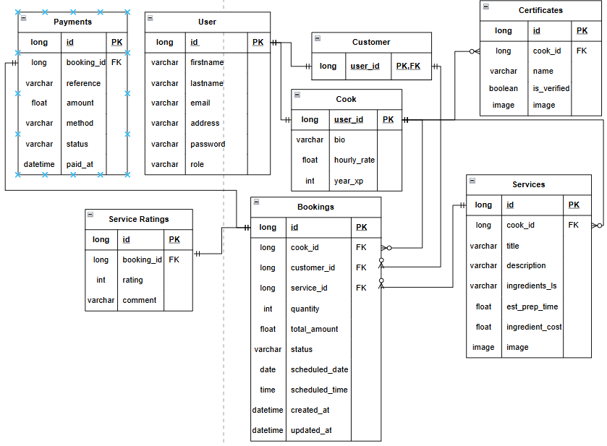

Detailed Relationships:
- One-to-One: User ↔ Cook (A cook is a user)
- One-to-One: User ↔ Customer (A customer is a user)
- One-to-Many: Cook → Service (A cook can offer multiple menu services)
- One-to-Many: Cook → Certificate (A cook can have multiple certificates)
- One-to-Many: Customer → Booking (A customer can have multiple bookings over time)
- One-to-Many: Cook → Booking (A cook can be assigned to multiple bookings)
- One-to-Many: Service → Booking (A specific service can be booked multiple times)
- One-to-One: Booking → Service Rating (A booking can only be rated one time)
- One-to-One: Booking → Payment (A booking can only have one payment)

Key Tables:
- users - User accounts, authentication, and baseclass for customer/ cook
- cooks - Extended profile for cooks
- customers - Extended profile for customers
- services - Specific offerings/ services of cooks (e.g., “Filipino breakfast”)
- certificates - Cook's personal certificates
- bookings - Booking transactions
- service_ratings - Rating of meal and service quality
- payments - Records of payments for bookings

Table Structure Summary:
- users: id, email, firstname, lastname, address, password, role(customer/cook)
- cooks: user_id, bio, hourly_rate, years_exp
- customers: user_id,
- services: id, cook_id, title, description, ingredients_ls, est_prep_time, ingredients_cost, image
- cook_certificates: id, cook_id, cert_name, is_verified, image
- bookings: id, customer_id, cook_id, service_id,quantity, total_amount, status, scheduled_date, scheduled_time, created_at, updated_at
- Service_ratings: id, booking_id, rating, comment
- payments - id, bookind_id, reference, method, amount, status, paid_at

7.0 UI/UX DESIGN
7.1 Web Application Wireframes
Landing page
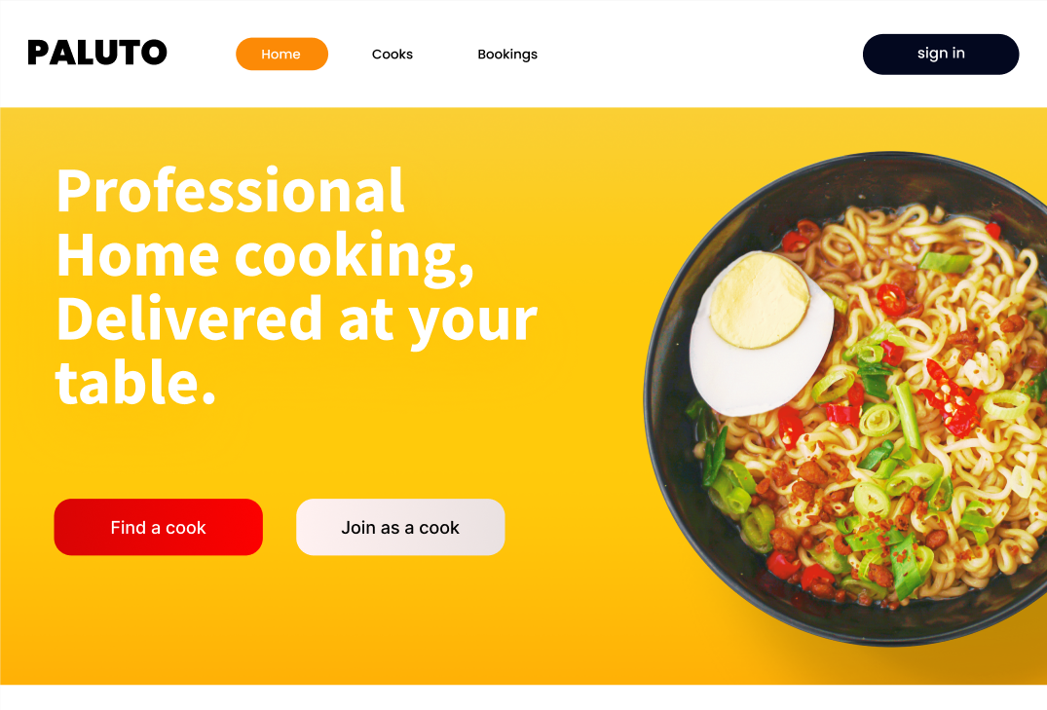
Header: [Logo] [Nav bar] [“sign in” button]
Main: Tagline, [“Find a cook” button] [“join as a cook” button]

Login Modal
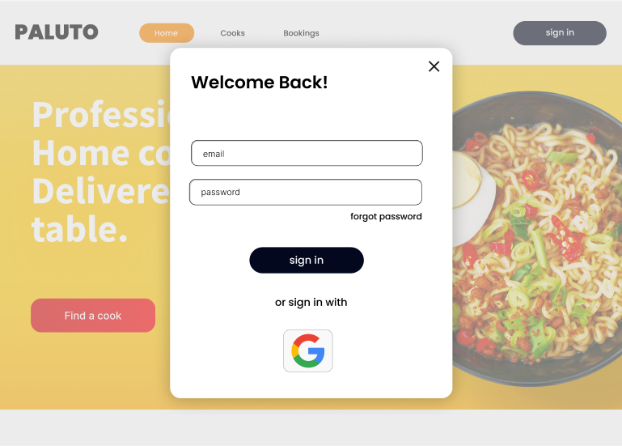
Login form, Google button, Forgot password, Close button

Cooks page (List of cooks)
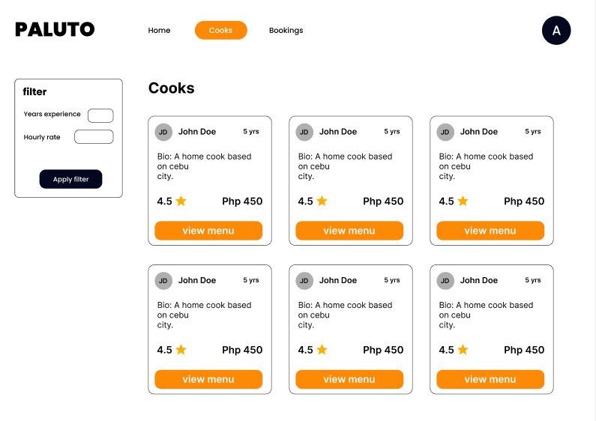
Header: [Logo] [Nav bar] [Profile]
Filter: Years of experience, hourly rate
Each cook card: Avatar, Full name, years of experience, Bio, rating, Hourly rate, “view menu” button

Cook’s menu
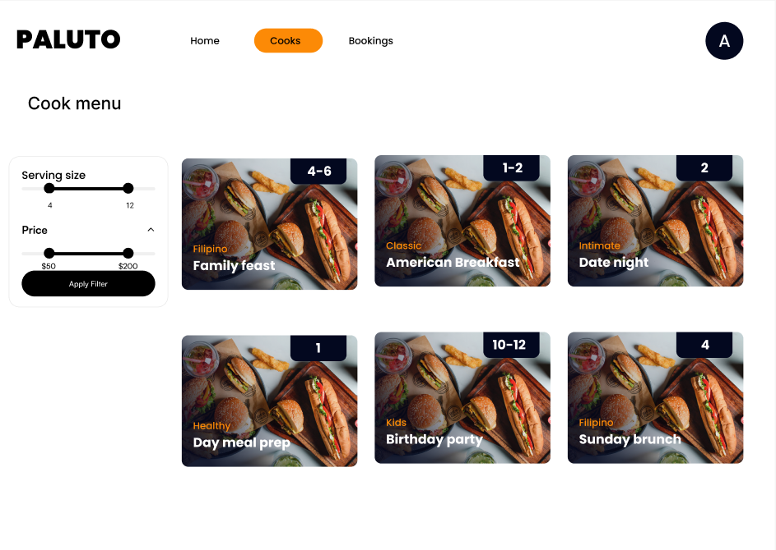
Header: [Logo] [Nav bar] [Profile]
Filter: Serving size, price
Each offering card: title, Serving size, offering image, title

Meal details
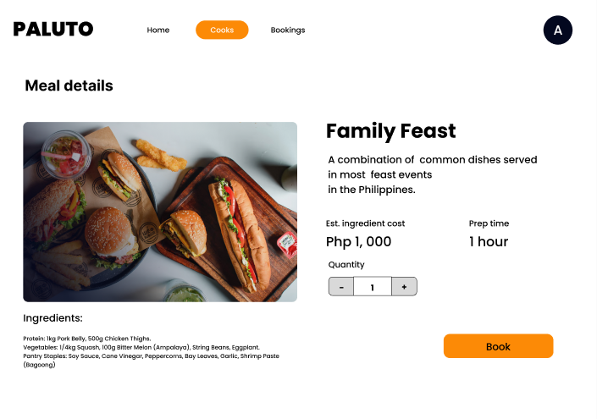
Header: [Logo] [Nav bar] [Profile]
Meal image(Large), title, description, ingredients, ingredient cost, prep time, quantity stepper (default to 1), “Book” button

Payment page
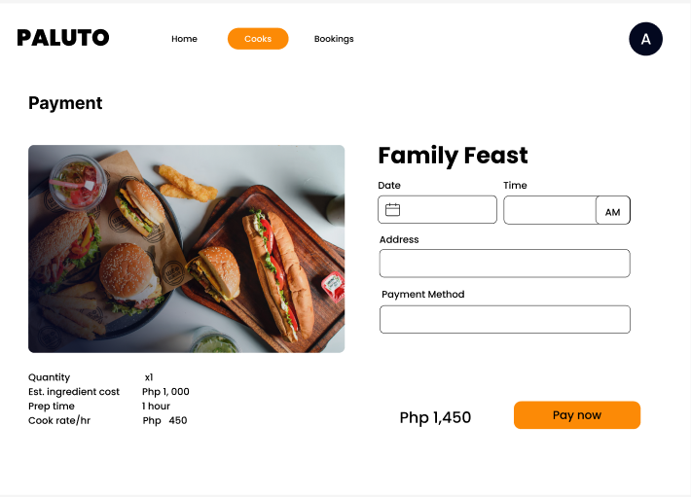
Header: [Logo] [Nav bar] [Profile]
Summary: Quantity, ingredient cost, prep time, cook’s rate per hour
Title, Date picker, time picker, address field, payment method field, total cost, “Pay now” button

Bookings page (pending)
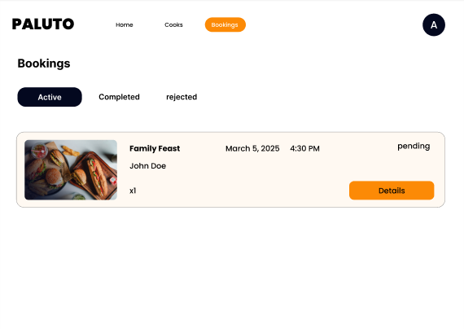
Header: [Logo] [Nav bar] [Profile]
Sub nav bar: Active, Completed, rejected
Each booking card: Meal image(small), title, cook's name, quantity, date, time, status, “Details” button.

Cook dashboard
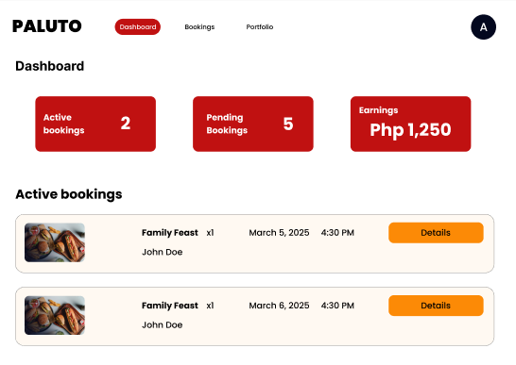
Header: [Logo] [Nav bar] [Profile]
KPI: Active bookings, Pending bookings, Earnings
Each active booking card: Meal image(small), title, quantity, customer name, date, time, “Details” button

Cook bookings (pending)
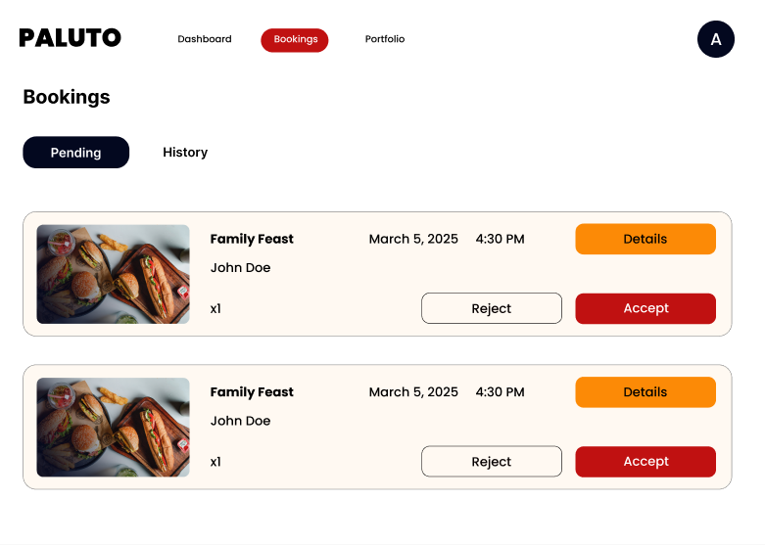
Header: [Logo] [Nav bar] [Profile]
Each booking card: meal image(small), title, customer name, quantity, date, time, “details” button, “Reject” button, “Accept” button.

Customer bookings (accepted bookings)
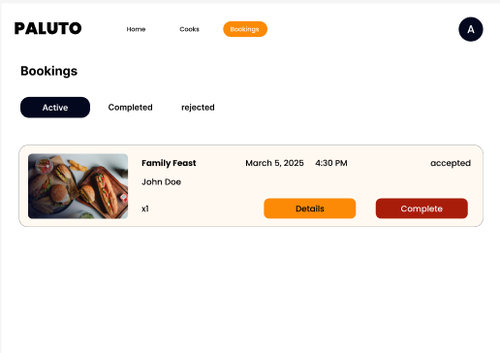
Header: [Logo] [Nav bar] [Profile]
Each booking card: meal image(small), title, customer name, quantity, date, time, status, “details” button, “Complete” button

Customer bookings (completed bookings)
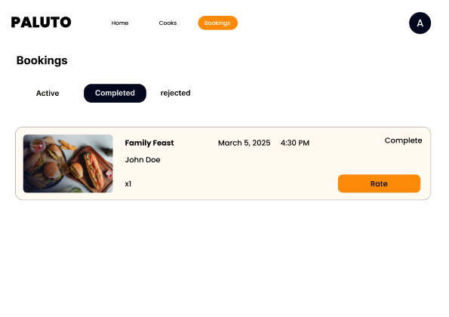
Header: [Logo] [Nav bar] [Profile]
Each booking card: meal image(small), title, customer name, quantity, date, time, status, “rate” button

7.2 Mobile Application Wireframes
Customer Bottom Navigation

Items: Home, Cooks, Bookings

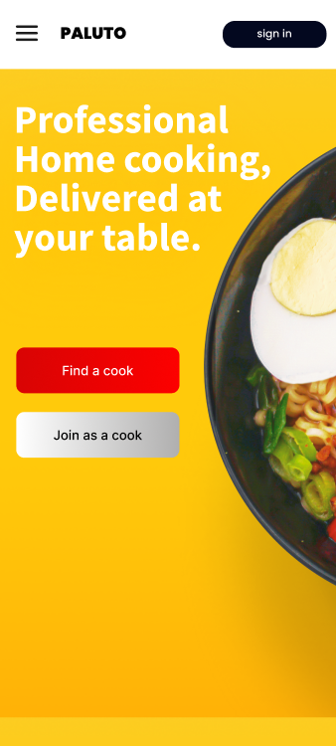
Landing screen
Header: Hamburger menu, Logo, “sign in” button
Main: “Find a cook” button, “Join as a cook” button

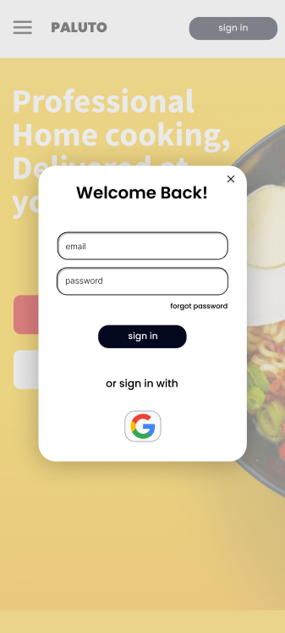
Login Modal
Fields: Email, password
Forgot password, “sign in” button, sign in with “Google” button

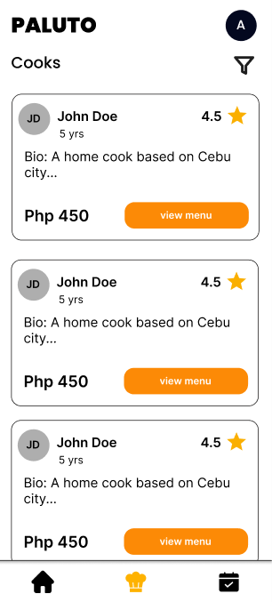
Cooks screen (List of cooks)
Header: Logo, Profile
Each cook card: Fullname, avatar, rating, bui, rate per hour, “view menu” button
filter icon, customer bottom navigation

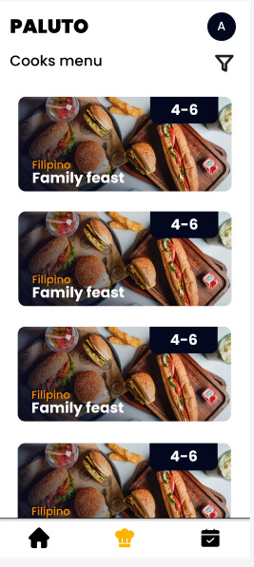
Cook’s menu
Header: Logo, Profile
Each menu card: title, serving size, offering image (background)
filter icon, bottom navigation

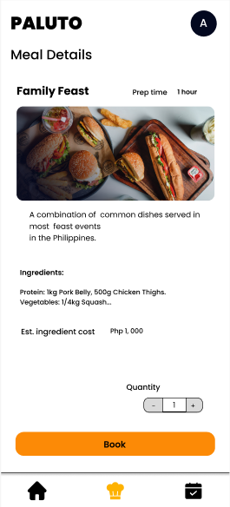
Meal details

Header: Logo, Profile
title, prep time, meal image (medium), description, ingredients, ingredients cost, quantity stepper (Default to 1)
bottom navigation

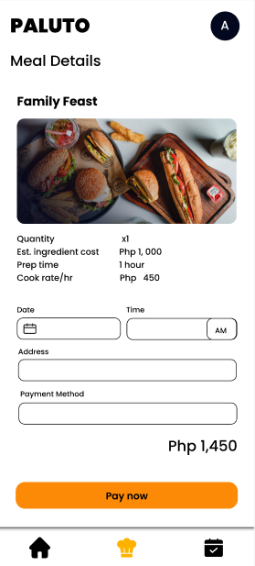
Payment screen
Header: Logo, Profile
Summary: Quantity, ingredient cost, prep time, cook’s rate per hour
Title, Date picker, time picker, address field, payment method field, total cost, “Pay now” button
bottom navigation

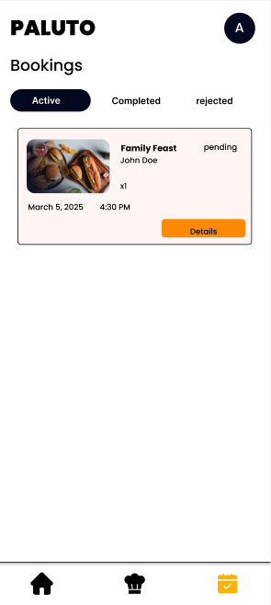
Bookings screen (pending)
Header: Logo, Profile
Screen nav bar: Active, Completed, rejected
Each booking card: Meal image(small), title, cook's name, quantity, date, time, status, “Details” button.
Bottom navigation

Cook’s bottom navigation

Items: Dashboard icon, Bookings icon, Portfolio icon
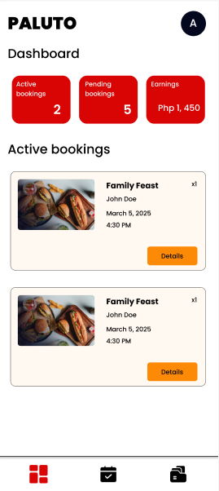
Cooks dashboard
Header: Logo, Profile
KPI: Active bookings, Pending bookings, Earnings
Each active booking card: Meal image(small), title, quantity, customer name, date, time, “Details” button
Cook’s bottom navigation

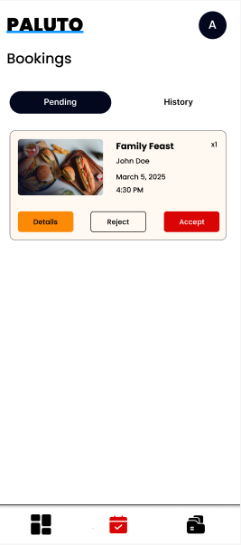
Cooks bookings (pending)
Header: Logo, Profile
Each booking card: meal image(small), title, customer name, quantity, date, time, “details” button, “Reject” button, “Accept” button.
Cook’s bottom navigation

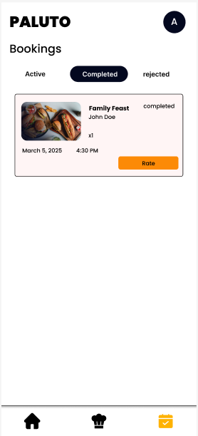
Customer bookings (accepted)
Header: Logo, Profile
Each booking card: meal image(small), title, customer name, quantity, date, time, status, “details” button, “Complete” button
Cook’s bottom navigation

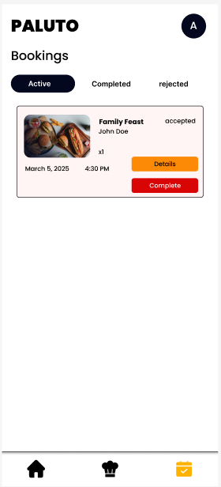
Customer bookings (completed)
Header: Logo, Profile
Each booking card: meal image(small), title, customer name, quantity, date, time, status, “rate” button
Cook’s bottom navigation

8.0 PLAN
8.1 Project Timeline
Phase 1: Planning & Design (Week 1-2)
Week 1: Requirements & Architecture
Day 1-2: Project setup and documentation
Day 3-4: Complete FRS and NFR
Day 5-7: System architecture design

Week 2: Detailed Design
Day 1-2: API specification
Day 3-4: Database design
Day 5-6: UI/UX wireframes
Day 7: Implementation plan finalization

Phase 2: Backend Development (Week 3-4)
Week 3: Foundation
Day 1: Spring Boot setup with dependencies
Day 2: Database configuration and entities
Day 3: JWT authentication & BCrypt password hashing implementation
Day 4: User management and /me endpoints
Day 5: Cook Portfolio CRUD operations

Week 4: Core Features
Day 1: Appointment/Booking transaction logic
Day 2: Service rating and file storage implementation
Day 3: Cooks and Menu filtering, Admin controls
Day 4: Error handling and validation
Day 5: API documentation and testing

Phase 3: Web Application (Week 5-6)
Week 5: Frontend Foundation
Day 1: React setup
Day 2: Authentication pages (login, register)
Day 3: Cook portfolio (menu, certs) and Cook listing page (Public view)
Day 4:Menu listing, menu details page
Day 5: Appointment booking form implementation

Week 6: Complete Web Features
Day 1: Appointment management (Accept/Decline flow for Cooks)
Day 2: Booking history, Status updates, and Rating system
Day 3: Admin dashboard for Cook certification moderation
Day 4: Responsive design polish
Day 5: API integration and End-to-End testing

Phase 4: Mobile Application (Week 7-8)
Week 7: Android Foundation
Day 1: Android Studio setup and project structure
Day 2: Authentication screens (JWT Login/Register)
Day 3: Cook browsing and Portfolio view (XML Layouts)
Day 4: Appointment request and Calendar interaction
Day 5: Retrofit API service layer and JWT secure storage

Week 8: Complete Mobile App
Day 1: Role-aware UI
Day 2: Appointment and status management
Day 3: UI polish and role-based menu filtering
Day 4: Testing on emulator/device
Day 5: APK generation and documentation

Phase 5: Integration & Deployment (Week 9-10)
Week 9: Integration Testing
Day 1: End-to-end testing across platforms
Day 2: Bug fixes and optimization
Day 3: Security review
Day 4: Performance testing
Day 5: Documentation updates

Week 10: Deployment
Day 1: Backend deployment (Railway/Heroku)
Day 2: Web app deployment (Vercel/Netlify)
Day 3: Mobile APK distribution
Day 4: Final testing
Day 5: Project submission
Milestones:
- M1 (End Week 2): All design documents complete
- M2 (End Week 4): Backend API (Auth & Booking) fully functional
- M3 (End Week 6): Web application complete
- M4 (End Week 8): Mobile application complete
- M5 (End Week 10): Full system deployed and integrated

Critical Path:
- Authentication system, Google OAuth login, and Role-based access control (Week 3)
- Cook portfolio API (Week 3-4)
- Booking Transaction Engine - Handling payments and status updates (Week 4)
- Conflict Resolution Logic - Ensuring the cook can't accept a booking with a similar timeline(Week 4)
- Role-Aware Mobile Navigation
- Cross-platform testing (Week 9)
Risk Mitigation:
- Start with the simplest working version of each feature
- Test integration points early and often
- Keep a backup of the working versions
- Focus on core functionality before enhancements
- Database Safety First
- Limit External API Scope

